Set up Personal DevOps Environment
Overview
This documentation guides you through building a personal DevOps environment—from setting up version control to CI/CD, Infrastructure as Code (IaC), and monitoring. It’s intended for individuals learning DevOps concepts, hobbyists, or small teams aiming to automate end-to-end development workflows.
Prerequisites
- A computer (Windows/macOS/Linux) with 8 GB + RAM (SSD preferred)
- Internet access (optional, for local-only labs)
- Accounts/CLI tools
- Git + GitHub/GitLab/Bitbucket
- Docker & Docker Compose installed
- Code editor (e.g. Visual Studio Code)

1. Version Control Systems
- Use Git (e.g., GitHub, GitLab) for source control. It’s the foundation of your pipeline, enabling branching, pull requests, and history tracking.
- Download and configure git in your windows.
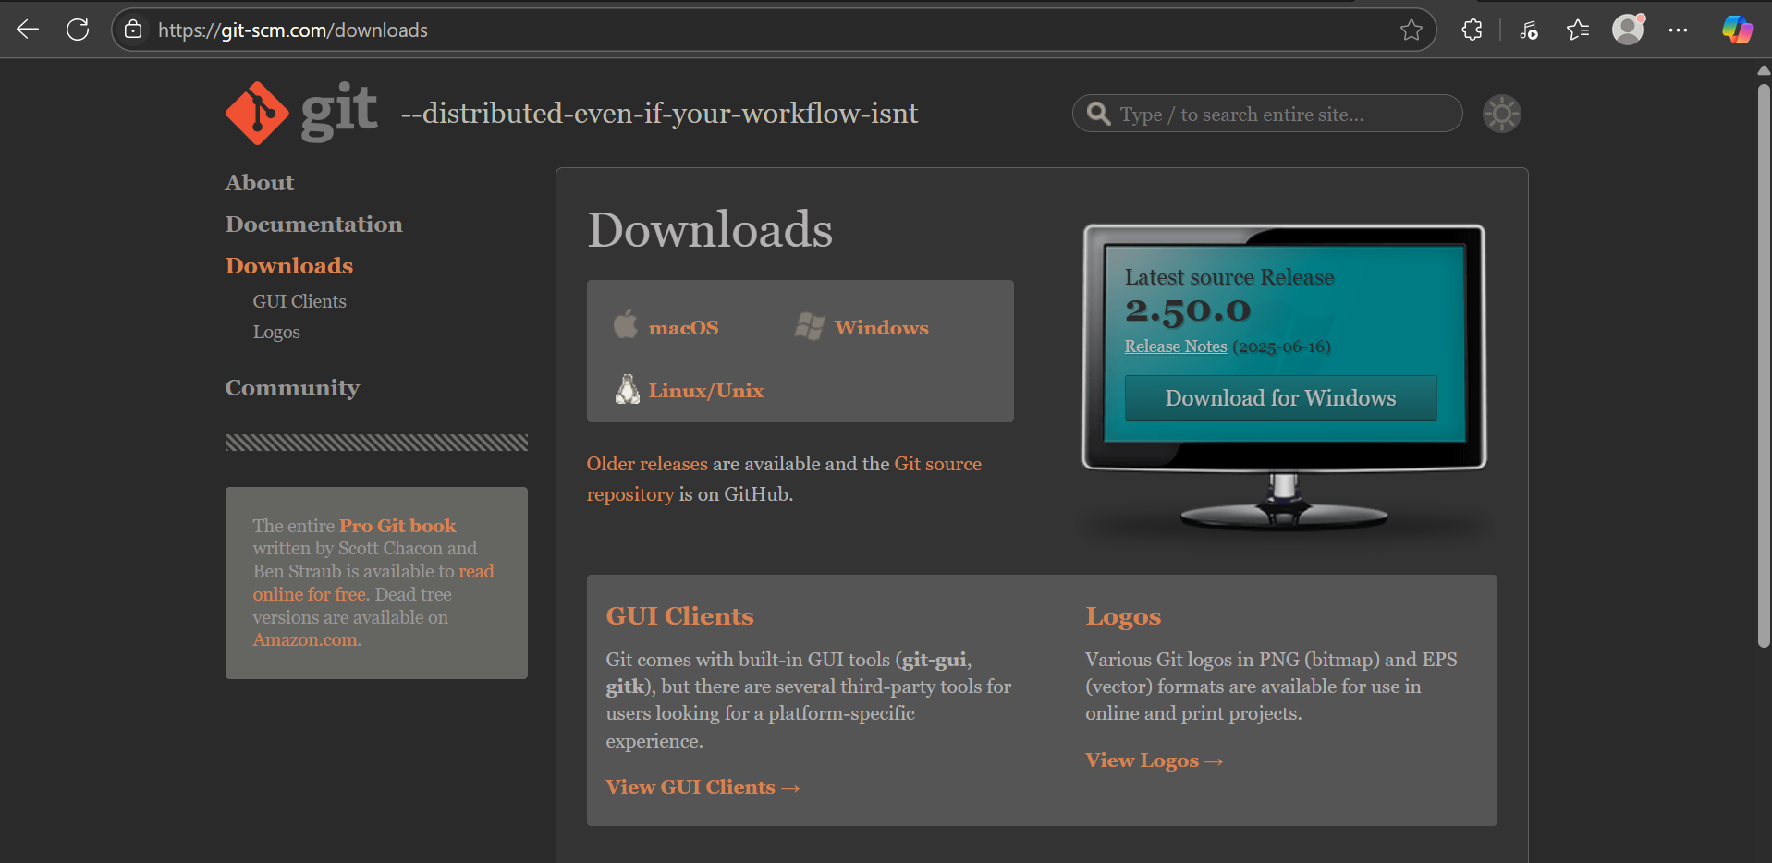

- Let’s install it on our device.
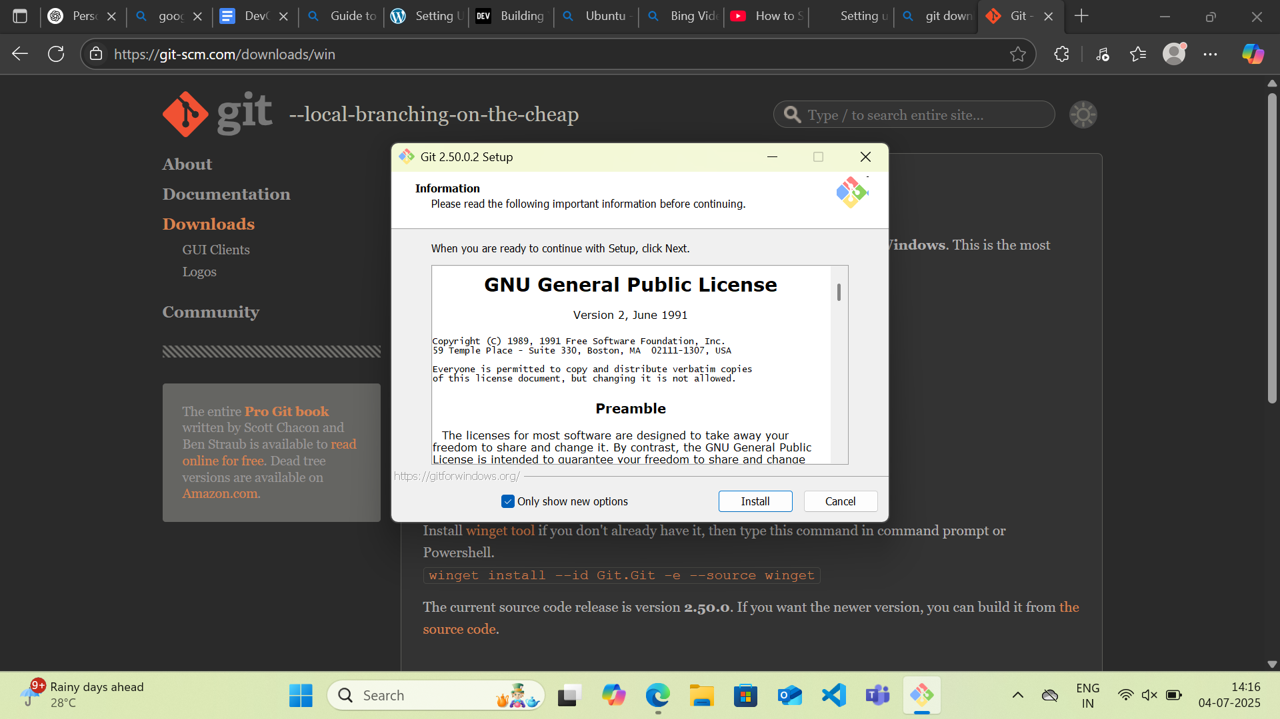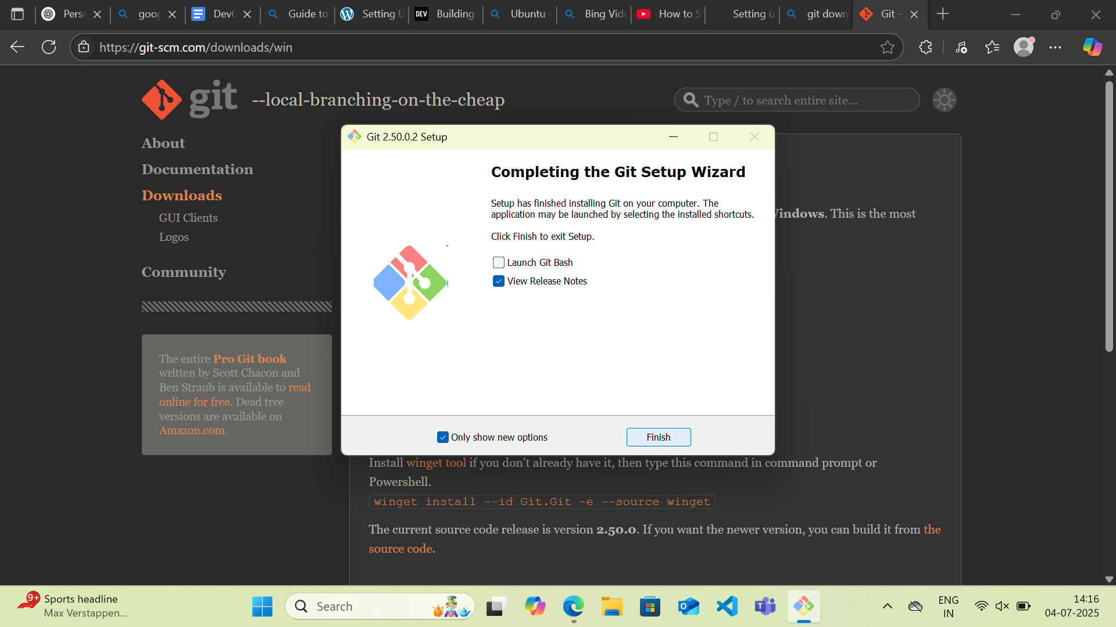
- Git is successfully installed.
2. Install Ubuntu
Here are the steps to install Ubuntu in Windows:
- Open your terminal
- Run the command : wsl --install -d Ubuntu
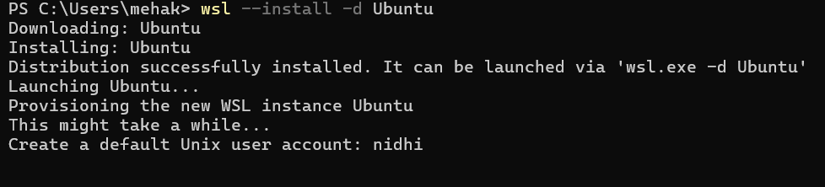
- Now, create your default user account and set up a new password.
- Ubuntu is successfully installed on your computer.
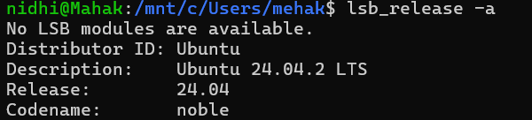
- To check the version, you can execute the command : lsb_release -a

3. Setup Package Manager
Let’s Setup Package Manager for Windows which is chocolatey
- Open PowerShell as Administrator.
- Set execution policy and run install script:
GET-ExecutionPolicy
SET-ExecutionPolicy Unrestricted
SET-ExecutionPolicy Bypass -Scope Process

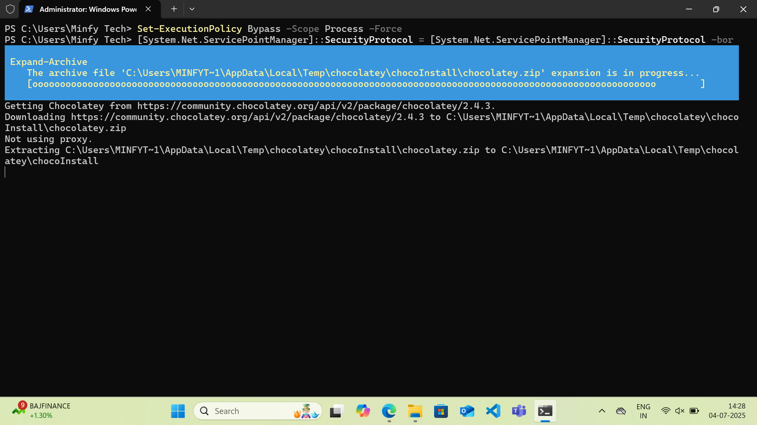
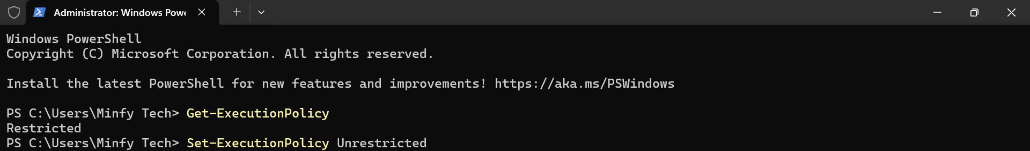
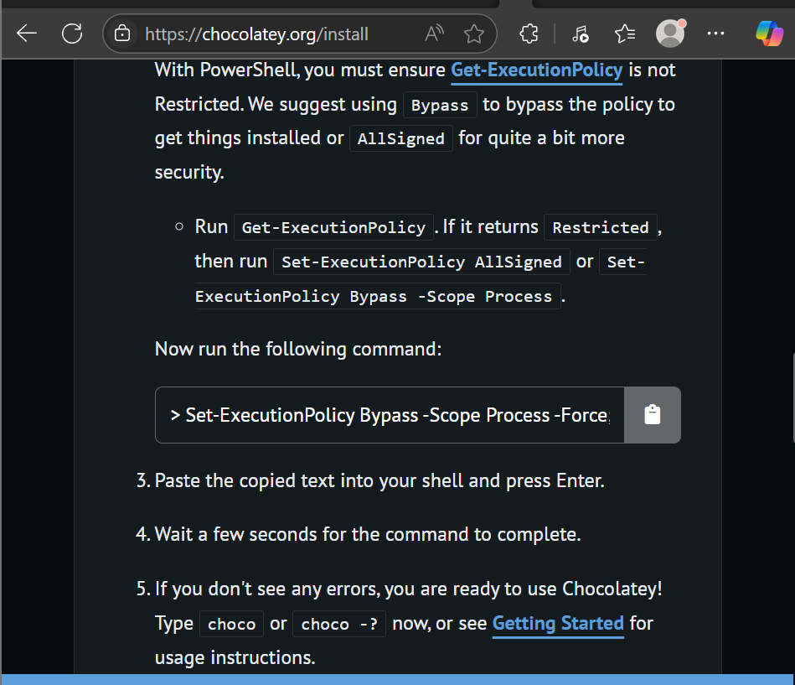
Chocolatey successfully installed.

Now using Chocolatey let’s install :
- Visual Studio Code
- Open the Powershell
- Check the version of choco: choco --version
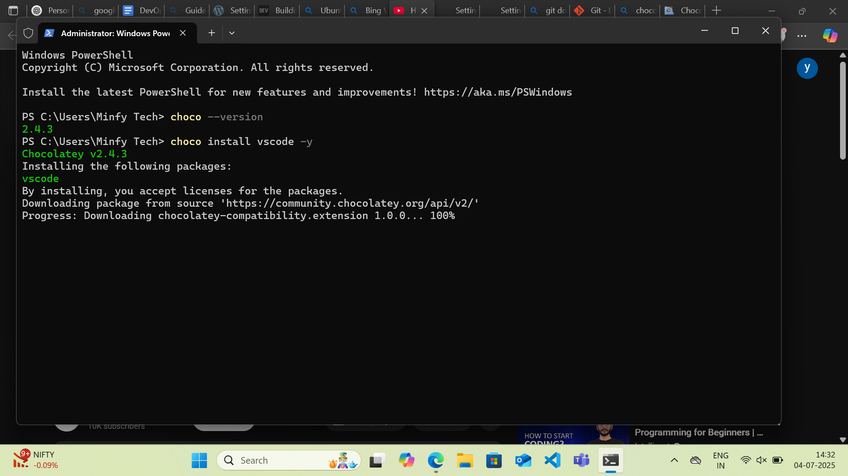
- Run the command : choco install vscode -y
Vs code is successfully installed.
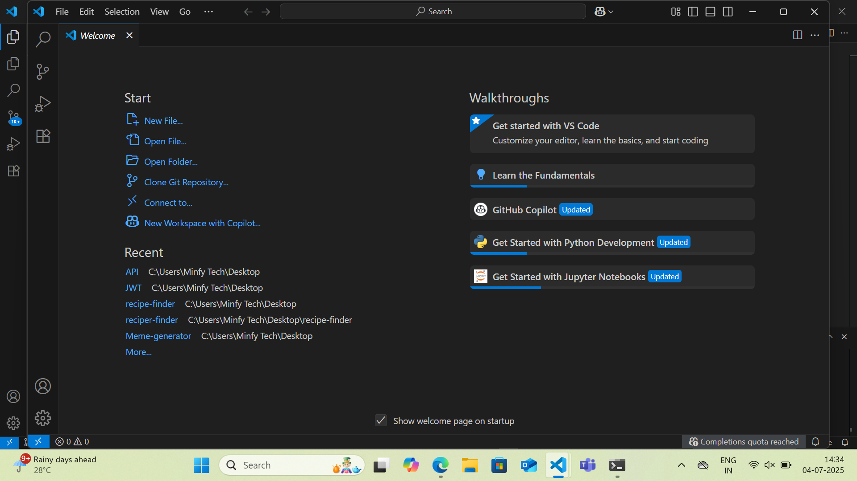
You can open VS Code in your local machines.

2. Terraform
- Run the command: choco install terraform
- Do you want to run the script?
Write: y
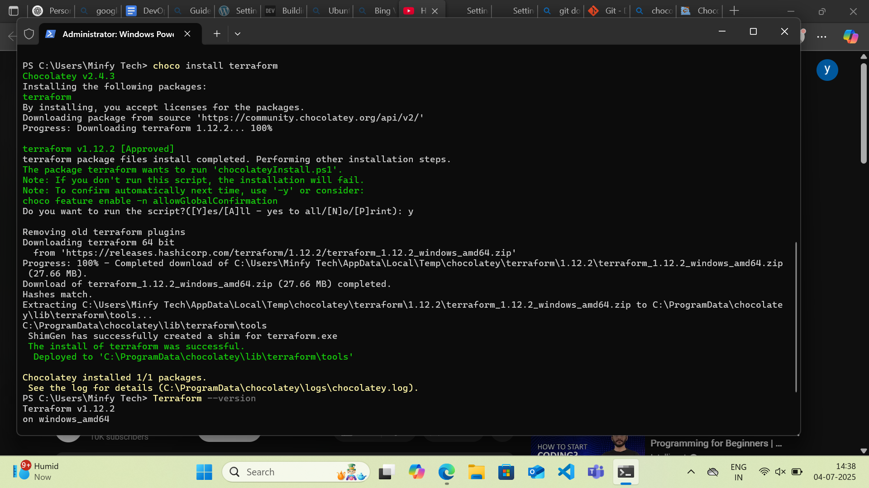
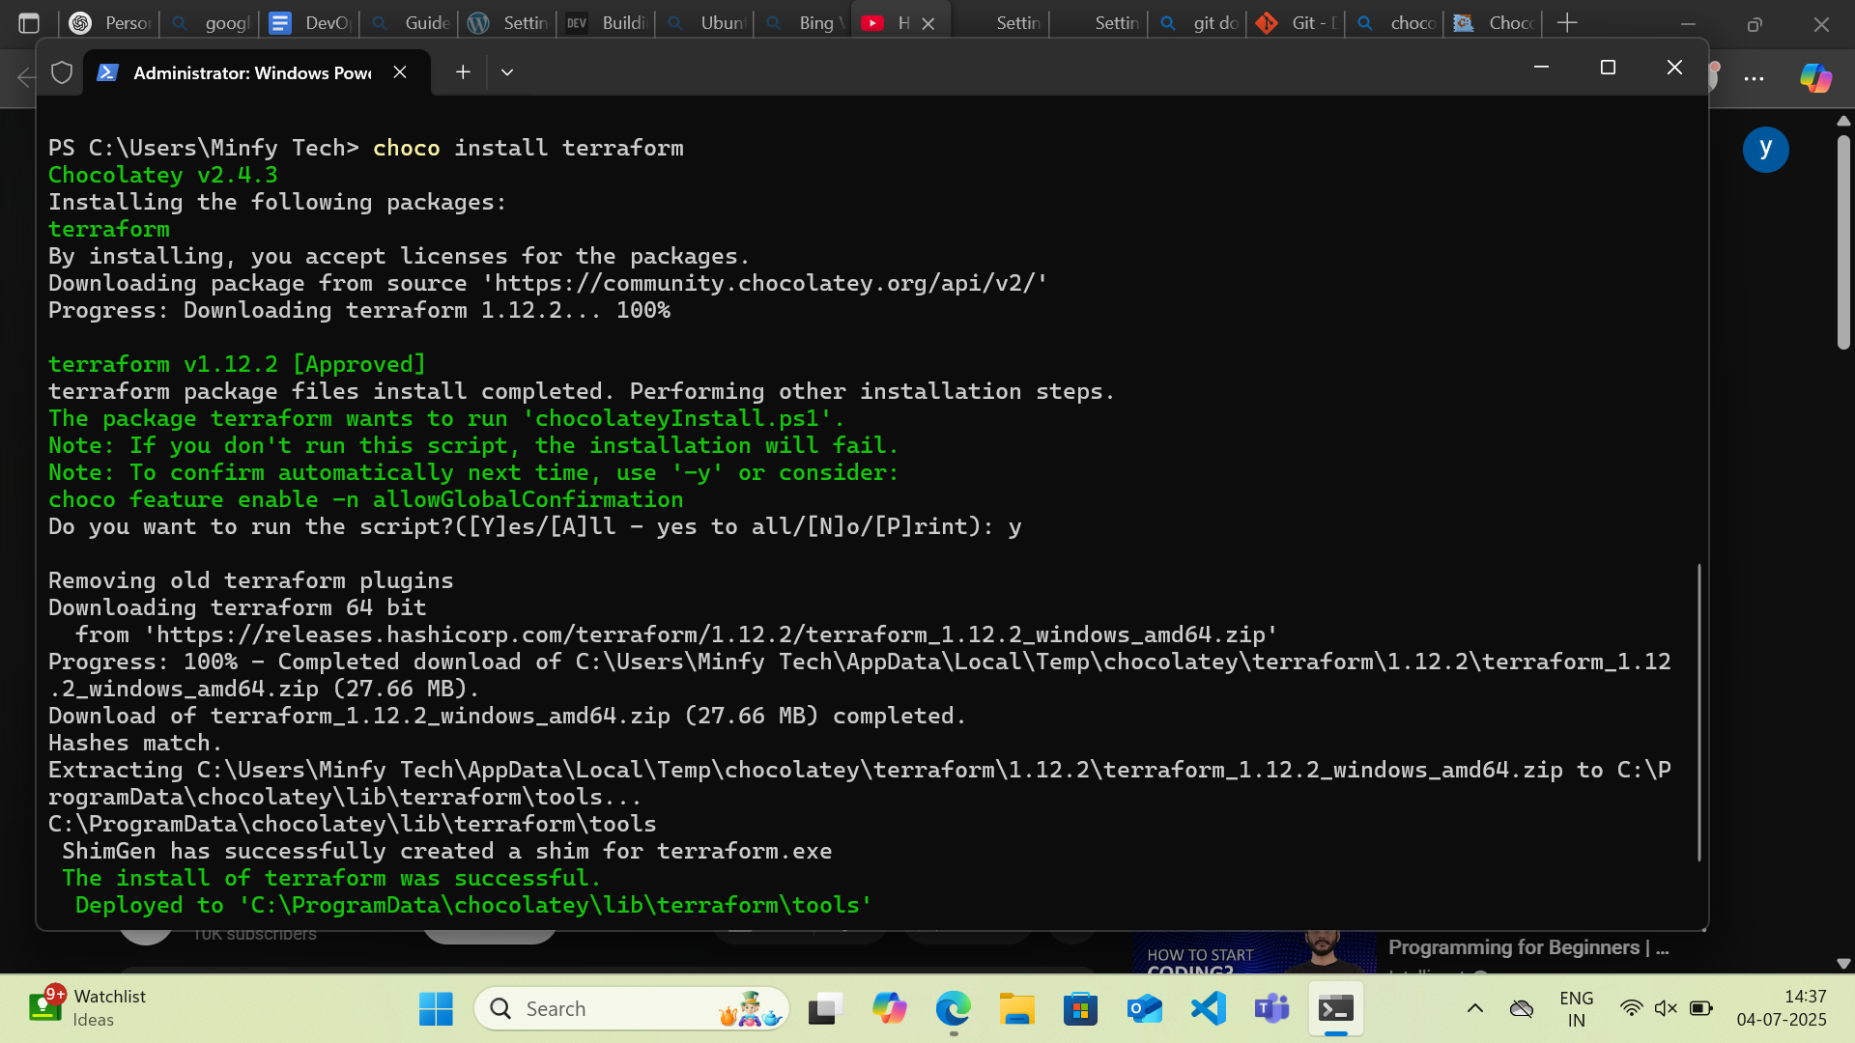
- To verify run: terraform --version
Terraform successfully installed
3. Install Docker
- Command: choco install docker
- Do you want to run the script?
Write: y
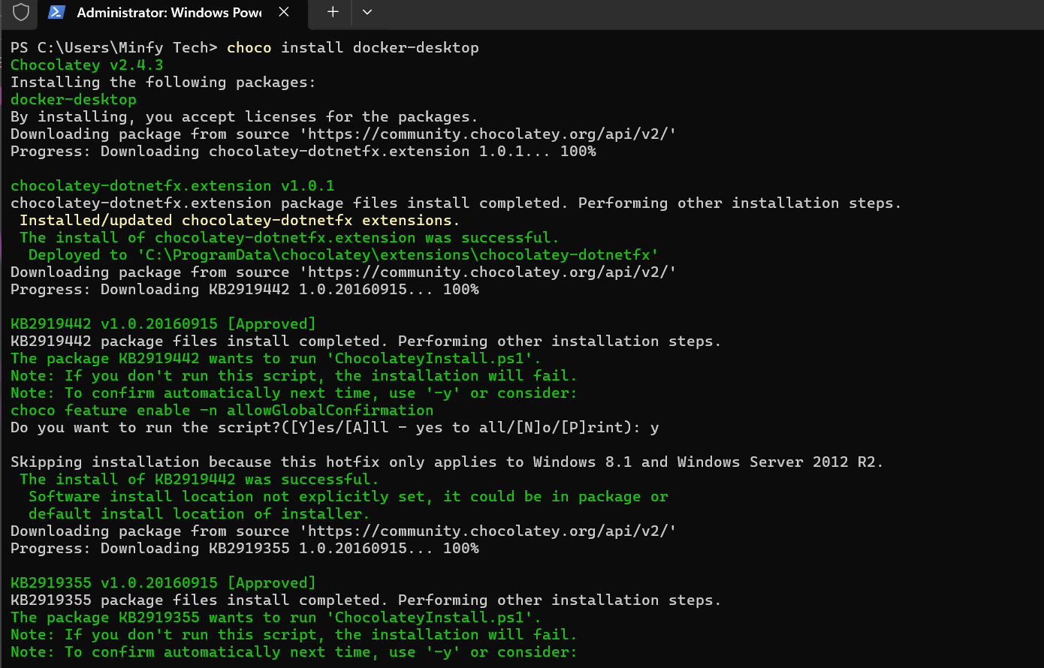
- To verify run: docker --version
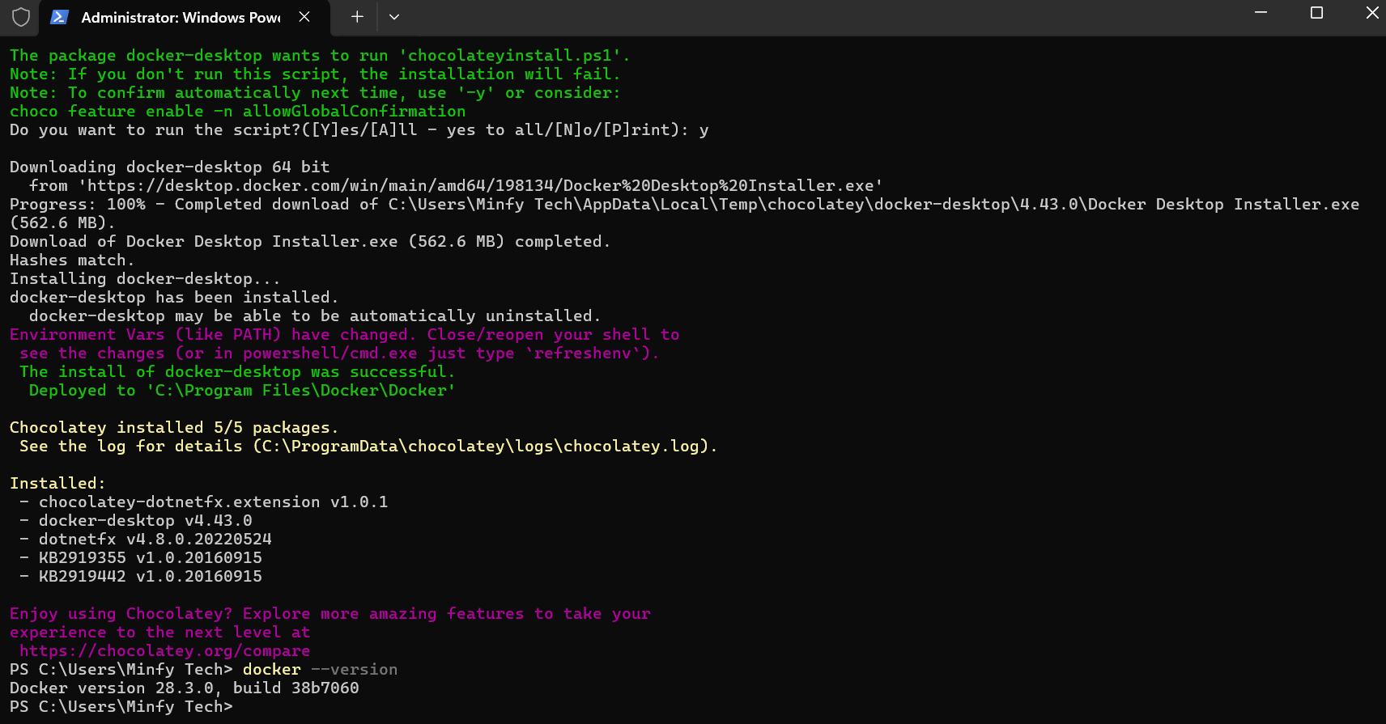
Docker Successfully Installed.

